* 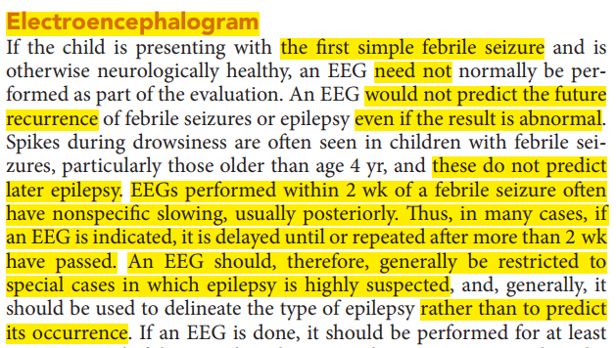
* Seizures are possibly the most important and common indicator of  
  significant neurologic dysfunction in the neonatal period. Seizure incidence is higher during this period than in any other period in life
* 
 